Pharmacological Effects of Medicinal Plant-Based Interventions on Lipid Profiles in Adults with Dyslipidemia: A Systematic Review of Clinical Evidence

ABSTRACT
Dyslipidemia remains a major modifiable driver of cardiovascular risk, while limitations of long-term lipid-lowering therapy have encouraged careful evaluation of adjunct pharmacological strategies from medicinal plants. This systematic review synthesized clinical evidence published from 2016 to 2025 on plant-based interventions for lipid profile improvement in adults with dyslipidemia or related metabolic conditions. PubMed, ScienceDirect, Cochrane Library, Wiley Online Library, and ProQuest were searched for randomized controlled and quasi-experimental studies reporting total cholesterol, LDL-C, HDL-C, or triglycerides. Study selection, data extraction, methodological appraisal, and risk-of-bias assessment followed PRISMA 2020 principles. Twenty-four interventional studies were included. The most consistent improvements were observed for total cholesterol and LDL-C, particularly with bergamot, garlic-based preparations, amla, Curcuma-derived products, artichoke preparations, green tea, ginger, and fenugreek. Effects on HDL-C and triglycerides were less uniform and appeared to depend on baseline metabolic phenotype, intervention duration, dosage, and formulation standardization. Reported mechanisms included inhibition of cholesterol biosynthesis, antioxidant and anti-inflammatory activity, improved insulin sensitivity, enhanced fatty-acid oxidation, and modulation of AMPK, SIRT1, and cholesterol efflux pathways. Overall, medicinal plant-derived interventions show clinically relevant lipid-modifying potential as adjunct strategies in dyslipidemia management; however, routine pharmaceutical application requires better standardization of active compounds, longer follow-up, and trials designed to evaluate safety, adherence, and clinically meaningful cardiometabolic outcomes.
Keywords: Dyslipidemia; Medicinal plants; Pharmacology; Phytotherapy; Lipid profile

INTRODUCTION
Dyslipidemia is a central and modifiable contributor to cardiovascular disease, particularly through elevated total cholesterol (TC), increased low-density lipoprotein cholesterol (LDL-C), reduced high-density lipoprotein cholesterol (HDL-C), and raised triglycerides (TG). Its clinical importance has increased alongside the growing global burden of obesity, type 2 diabetes mellitus (T2DM), metabolic syndrome, and non-alcoholic fatty liver disease, conditions that often cluster with atherogenic lipid abnormalities.¹₋⁶
Statins and other lipid-lowering medicines remain the foundation of dyslipidemia management, but their use in practice is not always straightforward. Intolerance, perceived adverse effects, low adherence, cost barriers in some settings, and residual cardiovascular risk despite lipid control have created a realistic need for complementary strategies that are pharmacologically plausible rather than merely traditional or empirical.⁷,⁸
Medicinal plants are increasingly examined as sources of lipid-modifying bioactive compounds. Garlic, turmeric, green tea, bergamot, amla, and artichoke have been investigated for effects on cholesterol synthesis, oxidative stress, inflammation, insulin sensitivity, and hepatic lipid handling.⁹-¹⁴ These mechanisms are relevant to pharmaceutical sciences because they connect phytochemical composition with measurable biological and clinical outcomes.
Although several reviews have assessed individual plants or narrower metabolic conditions, the clinical evidence remains scattered across different populations, formulations, doses, and outcome measures.¹⁵-¹⁶ Therefore, this review aimed to synthesize recent clinical evidence on medicinal plant-based interventions for lipid profile improvement in adults with dyslipidemia or related metabolic disorders, with emphasis on pharmacological mechanisms, comparative response patterns, and implications for standardized phytotherapeutic development.

Materials and Methods

Study design and reporting guideline
This systematic review was designed to evaluate the pharmacological and clinical effects of medicinal plant-based interventions on lipid profiles in adult populations. Reporting followed the PRISMA 2020 statement to support transparency in study identification, eligibility assessment, and synthesis.¹⁷ The review was not registered in PROSPERO.

Search strategy
A structured search was conducted in PubMed, ScienceDirect, Cochrane Library, Wiley Online Library, and ProQuest for studies published from January 2016 to December 2025. Search terms combined concepts related to medicinal plants and lipid disorders, including “medicinal plants”, “herbal medicine”, “phytotherapy”, “plant extract”, “dyslipidemia”, “hyperlipidemia”, “cholesterol”, “lipid profile”, “clinical trial”, and “randomized controlled trial”. Search strings were adapted to the syntax of each database, and reference lists of included studies were screened manually.

Eligibility criteria
Studies were eligible if they involved adults aged 18 years or older, evaluated single or combined medicinal plant-based interventions, used randomized controlled or quasi-experimental designs, and reported at least one lipid outcome, including TC, LDL-C, HDL-C, or TG. Studies were excluded if they were observational studies, animal or in vitro experiments, reviews, case reports, conference abstracts, pediatric studies, non-English publications, or interventions not primarily derived from medicinal plants.

Study selection and data extraction
Records were deduplicated before title and abstract screening. Potentially eligible reports were then assessed in full text. Extracted data included author, year, country, population, sample size, design, plant intervention, dose, duration, comparator, lipid outcomes, main findings, and proposed mechanisms. Data extraction focused on both clinical lipid responses and pharmacological interpretation.

Quality and risk-of-bias assessment
Methodological quality was assessed with Joanna Briggs Institute critical appraisal tools according to study design. Randomized trials were additionally assessed using RoB 2, while quasi-experimental studies were assessed using ROBINS-I. Appraisal results were interpreted narratively to avoid overstating certainty where allocation concealment, blinding, follow-up, or confounding control was incompletely reported.¹⁸-²⁰

Data synthesis
Because the included studies differed substantially in plant species, extracts, dosage, duration, baseline clinical condition, and outcome reporting, meta-analysis was not performed. A narrative synthesis was conducted by grouping findings according to lipid outcome and pharmacological category, including polyphenol-rich extracts, sulfur-containing Allium preparations, curcuminoids, flavonoid-based products, and fiber- or saponin-rich interventions.

RESULTS
The included studies were also analyzed based on pharmacological characteristics of the interventions, including type of extract, formulation, dosage, and duration of treatment.
A systematic search of electronic databases identified a total of 1,248 records. After removal of duplicates, 982 records remained for screening. Following title and abstract screening, 947 records were excluded due to irrelevance, including non-clinical studies, non-medicinal plant interventions, and studies not addressing lipid outcomes.
A total of 35 full-text articles were assessed for eligibility. Of these, 11 studies were excluded for the following reasons: non-interventional design (n = 4), absence of lipid profile outcomes (n = 3), combined intervention to non-medicinal plant interventions (n = 2), and animal subject (n = 2). Ultimately, 24 studies were included in the qualitative synthesis.

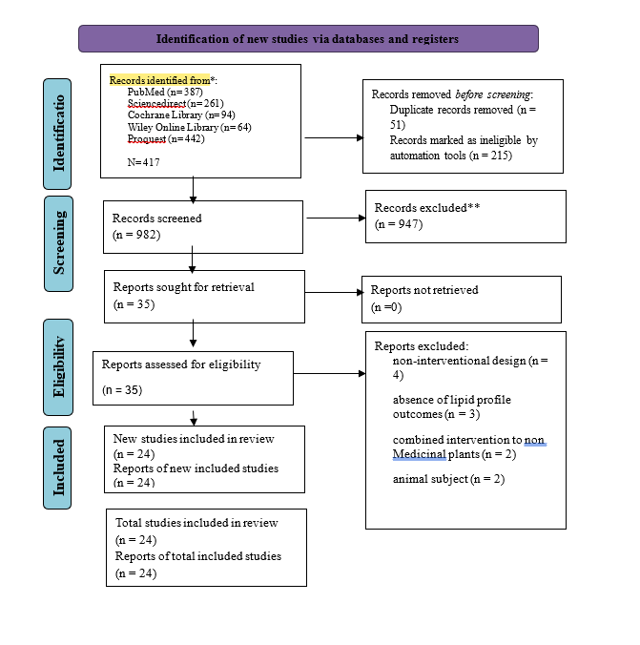
Figure 1. PRISMA Flow Diagram of Study Selection

Table 1. Characteristics of Included Interventional Studies Evaluating Medicinal Plant-Based Interventions on Lipid Profiles
Author (Year) | Country | Population | Sample | Design | Plant | Dose | Duration | Comparator | Outcomes | Main Findings | Proposed Mechanisms
Donato (2020)²¹ | Italy | Adults with hypercholesterolemia | 90 | DB-RCT | Guggulu + Triphala | NR | 3 mo + follow-up | Placebo | TC, LDL, HDL, TG | ↓ TC, LDL (within group), NS vs placebo | FXR antagonism, antioxidant, anti-inflammatory
Adab (2019)²² | Iran | T2DM with hyperlipidemia | 75 | DB-RCT | Turmeric | 2100 mg/day | 8 weeks | Placebo | TC, LDL, HDL, TG | ↓ TC, LDL, TG (between-group) | Antioxidant, anti-inflammatory, oxidative stress reduction
Ajamzibad (2021)²³ | Iran | Hyperlipidemia adults | 28 | Quasi | Garlic + lemon | 10 cc/meal | 3 weeks | Pre-post | TC, LDL, HDL, TG | ↓ TC, LDL, TG; ↑ HDL | HMG-CoA reductase inhibition, polyphenol activity
Arzati (2017)²⁴ | Iran | T2DM | 45 | DB-RCT | Ginger | 2000 mg/day | 10 weeks | Placebo | LDL/HDL ratio, lipid panel | ↓ LDL/HDL ratio; others NS | Anti-inflammatory, metabolic modulation
Ashraf (2022)²⁵ | Pakistan | Hypertension + dyslipidemia | NR | RCT | Garlic | 0.3–1.5 g/day | 24 weeks | Placebo + statin | TC, LDL, HDL, TG | ↓ TC, LDL, TG; ↑ HDL | HMG-CoA inhibition, anti-LDL oxidation
Bazyar (2020)²⁶ | Iran | T2DM | 50 | DB-RCT | Green tea (EGCG) | 300 mg/day | 8 weeks | Placebo | TC, TG, AIP | ↓ TC, TG, AIP | Antioxidant, anti-inflammatory, improved oxidative status
Cai (2017)²⁷ | China | Older adults with dyslipidemia | 98 | DB-RCT | Citrus bergamia | NR | 12 weeks | Placebo | LDL, TC, TG | ↓ LDL (significant), TC/TG ↓ trend | HMG-CoA inhibition, antioxidant
Carvalho (2020)²⁸ | Brazil | T2DM | 103 | DB-RCT | Ginger | 1.2 g/day | 90 days | Placebo | TC, glycemic markers | ↓ TC modestly | Anti-inflammatory, insulin modulation
Rezazadeh (2017)²⁹ | Iran | Women with metabolic syndrome | 50 | DB-RCT | Artichoke | 1800 mg/day | 12 weeks | Placebo | TG, TC, LDL | ↓ TG (significant), others limited | Polyphenols (luteolin, chlorogenic acid)
El Gayar (2019)³⁰ | Egypt | Obese T2DM | 80 | RCT | Ginger | 1.8 g/day | 8 weeks | Placebo + metformin | TC, LDL, HDL, TG | ↓ TC, LDL, TG; ↑ HDL | ↑ thermogenesis, lipolysis, ↓ fat absorption
Geberemeskel (2019)³¹ | Ethiopia | T2DM | 114 | Clinical trial | Fenugreek | 25 g BID | 1 month | Metformin | TC, LDL, HDL, TG | ↓ TC, LDL, TG; ↑ HDL | Fiber/saponin-mediated lipid regulation
Majeed (2023)³² | India | Obese metabolic syndrome | 100 | DB-RCT | Calebin A (Curcuma) | 25 mg/day | 90 days | Placebo | LDL, HDL, TG | ↓ LDL, TG; ↑ HDL | ↑ fatty acid oxidation, anti-inflammatory
Panahi (2017)³³ | Iran | T2DM | 118 | DB-RCT | Curcuminoids | 1000 mg/day | 12 weeks | Placebo | TC, HDL, Lp(a), TG | ↓ TC, non-HDL, Lp(a); ↑ HDL | Anti-inflammatory, antioxidant
Rahimlou (2019)³⁴ | Iran | Metabolic syndrome | 37 | DB-RCT | Ginger | 2 g/day | 12 weeks | Placebo | TG, metabolic indices | ↓ TG significant | Improved insulin resistance
Rangboo (2016)³⁵ | Iran | NASH | 60 | DB-RCT | Artichoke | 2700 mg/day | 2 months | Placebo | TC, TG | ↓ TC, TG | ↓ ROS, hepatoprotective
Riva (2022)³⁶ | Italy | Mild hypercholesterolemia | 60 | DB-RCT | Bergamot + artichoke | 600 + 100 mg | 2 months | Placebo | TC, LDL | ↓ TC, LDL | Synergistic polyphenol effect
Rondanelli (2020)³⁷ | Italy | IFG overweight adults | 54 | DB-RCT | Cynara scolymus | 600 mg/day | 2 months | Placebo | HDL, LDL ratios | Improved lipid ratios | Enzyme inhibition (α-glucosidase, G6Pase)
Spina (2024)³⁸ | Italy | Hypercholesterolemia | 64 | DB-RCT | Citrus bergamia | 150 mg/day | 4 months | Placebo | TC, LDL, HDL | ↓ TC, LDL; ↑ HDL trend | AMPK, SIRT1 activation
Talaei (2017)³⁹ | Iran | T2DM | 81 | DB-RCT | Ginger | 3 g/day | 8 weeks | Placebo | LDL, ratios | ↓ LDL, LDL/HDL ratio | Anti-inflammatory
Upadya (2019)⁴⁰ | India | Dyslipidemia | 98 | DB-RCT | Amla | 500 mg BID | 12 weeks | Placebo | TC, LDL, TG, AIP | ↓ TC, LDL, TG, AIP | Antiatherogenic polyphenols
Vezza (2024)⁴¹ | Spain | Mild hypercholesterolemia | 66 | DB-RCT | Garlic + onion | 1 cap/day | 8 weeks | Placebo | LDL, TC | ↓ LDL, TC | Cholesterogenesis inhibition, cholesterol efflux
Yazdanpanah (2023)⁴² | Iran | T2DM nephropathy | 66 | RCT | Green tea | 2–3 cups/day | 12 weeks | Control | TC, HDL | ↓ TC; ↑ HDL | Antioxidant, anti-inflammatory
Zamani (2018)⁴³ | Iran | NAFLD | 85 | DB-RCT | Zataria multiflora | 1400 mg/day | 12 weeks | Placebo | Lipid panel | No significant lipid change | Insulin sensitivity, anti-inflammatory
Zeb (2018)⁴⁴ | Pakistan | Hyperlipidemia + CVD | 80 | RCT (single-blind) | Garlic + coriander | 2 g/day | 60 days | Placebo | TC, LDL, HDL, TG | ↓ TC, LDL, TG; ↑ HDL | HMG-CoA inhibition + antioxidant synergy

Characteristics of Included Studies
A total of 24 interventional studies were included in this review.²¹⁻⁴⁴ Most were randomized controlled trials, and the majority adopted double-blind, placebo-controlled designs, although a smaller number used single-blind or quasi-experimental approaches. Collectively, these studies were conducted across a wide geographical range, including Iran, India, China, Pakistan, Ethiopia, Egypt, Brazil, Italy, and Spain, indicating that interest in plant-based dyslipidemia management spans multiple health systems and dietary contexts. The included populations were heterogeneous, comprising adults with primary dyslipidemia or hypercholesterolemia, as well as adults with dyslipidemia-associated metabolic conditions such as type 2 diabetes mellitus (T2DM), metabolic syndrome, impaired fasting glucose, non-alcoholic fatty liver disease (NAFLD), non-alcoholic steatohepatitis (NASH), diabetic nephropathy, and hypertension.
(Adab et al., 2019; Ajamzibad et al., 2021; Arzati et al., 2017; Ashraf et al., 2022; Bazyar et al., 2021; Cai et al., 2017; Carvalho et al., 2020; Donato et al., 2021; El Gayar et al., 2019; Geberemeskel et al., 2019; Majeed et al., 2023; Panahi et al., 2017; Rahimlou et al., 2019; Rangboo et al., 2016; Rezazadeh et al., 2018; Riva et al., 2022; Rondanelli et al., 2020; Spina et al., 2024; Talaei et al., 2017; Upadya et al., 2019; Vezza et al., 2024; Yazdanpanah et al., 2023; Zamani et al., 2018; Zeb et al., 2018)The medicinal plant interventions were also diverse, ranging from single botanical preparations such as ginger, turmeric, green tea, fenugreek, artichoke, amla, bergamot, Zataria multiflora, and garlic, to combination products such as bergamot-artichoke phytosome, garlic-onion extract, garlic-coriander powder, boiled garlic with Shirazi lemon, and Guggulu-Triphala preparations. Intervention durations ranged from 3 weeks to 24 weeks, with most studies lasting 8-12 weeks.²¹⁻⁴⁴
Quality Assessment
Table 2. Methodological Quality Assessment of Randomized Controlled Trials Using the Joanna Briggs Institute (JBI) Critical Appraisal Checklist
Study | 1 | 2 | 3 | 4 | 5 | 6 | 7 | 8 | 9 | 10 | 11 | 12 | Overall
Donato (2020)²¹ | Y | U | Y | Y | Y | U | Y | Y | U | Y | Y | Y | High
Adab (2019)²² | Y | U | Y | Y | Y | U | Y | Y | U | Y | Y | Y | High
Arzati (2017)²⁴ | Y | U | Y | Y | Y | U | Y | Y | U | Y | Y | Y | High
Ashraf (2022)²⁵ | Y | U | Y | N | N | U | Y | Y | U | Y | Y | Y | Moderate
Bazyar (2020)²⁶ | Y | Y | Y | Y | Y | Y | Y | Y | U | Y | Y | Y | High
Cai (2017)²⁷ | Y | Y | Y | Y | Y | Y | Y | Y | U | Y | Y | Y | High
Carvalho (2020)²⁸ | Y | U | Y | Y | Y | U | Y | N | N | Y | Y | Y | Moderate
Rezazadeh (2017)²⁹ | Y | Y | Y | Y | Y | Y | Y | Y | U | Y | Y | Y | High
El Gayar (2019)³⁰ | Y | U | Y | N | N | U | Y | Y | U | Y | Y | Y | Moderate
Majeed (2023)³² | Y | Y | Y | Y | Y | Y | Y | Y | U | Y | Y | Y | High
Panahi (2017)³³ | Y | Y | Y | Y | Y | Y | Y | Y | U | Y | Y | Y | High
Rahimlou (2019)³⁴ | Y | U | N | Y | Y | U | Y | Y | U | Y | Y | Y | Moderate
Rangboo (2016)³⁵ | Y | Y | Y | Y | Y | Y | Y | Y | U | Y | Y | Y | High
Riva (2022)³⁶ | Y | Y | Y | Y | Y | Y | Y | Y | U | Y | Y | Y | High
Rondanelli (2020)³⁷ | Y | U | Y | Y | Y | U | Y | Y | U | Y | Y | Y | High
Spina (2024)³⁸ | Y | Y | Y | Y | Y | Y | Y | Y | U | Y | Y | Y | High
Talaei (2017)³⁹ | Y | U | Y | Y | Y | U | Y | Y | U | Y | Y | Y | High
Upadya (2019)⁴⁰ | Y | Y | Y | Y | Y | Y | Y | Y | U | Y | Y | Y | High
Vezza (2024)⁴¹ | Y | Y | Y | Y | Y | Y | Y | Y | U | Y | Y | Y | High
Yazdanpanah (2023)⁴² | Y | Y | Y | Y | Y | Y | Y | Y | U | Y | Y | Y | High
Zamani (2018)⁴³ | Y | U | Y | Y | Y | U | Y | Y | U | Y | Y | Y | High
Zeb (2018)⁴⁴ | Y | U | Y | N | N | U | Y | Y | U | Y | Y | Y | Moderate

The methodological quality of the 22 randomized controlled trials was assessed using the Joanna Briggs Institute (JBI) Critical Appraisal Checklist for RCTs (Table 2). Overall, the included trials demonstrated generally good methodological quality, with several strengths but also recurring limitations across specific domains.
All included studies explicitly reported the use of randomization, indicating that selection bias was minimized at the allocation stage. In addition, outcome measurements were consistently conducted using validated laboratory-based methods, and all studies employed appropriate statistical analyses, suggesting a low risk of measurement and analytical bias across the dataset.
Despite these strengths, allocation concealment was insufficiently reported in a substantial proportion of studies, with several trials failing to clearly describe the procedures used to prevent foreknowledge of group assignment. Similarly, although participant blinding was implemented in many trials, blinding of personnel and outcome assessors was inconsistently reported, and in several studies it remained unclear whether blinding was adequately maintained. These limitations indicate a potential risk of performance and detection bias in part of the evidence base.
Baseline comparability between intervention and control groups was generally acceptable, with most studies reporting similar demographic and clinical characteristics at baseline. However, a small number of trials exhibited baseline imbalances, which may have influenced the magnitude of observed treatment effects. In contrast, most studies ensured that groups were treated equally aside from the intervention, supporting internal validity.
Attrition was another domain with some variability. While the majority of trials reported acceptable follow-up rates, several studies experienced incomplete follow-up or did not fully account for dropouts, potentially introducing attrition bias. This concern is further reinforced by the observation that intention-to-treat (ITT) analysis was not consistently applied, with many studies relying on per-protocol analyses. The absence of ITT increases the likelihood that treatment effects may be overestimated.
Overall, while the majority of included randomized trials met key methodological criteria—particularly in terms of randomization, outcome measurement, and statistical analysis—limitations in allocation concealment, blinding, and handling of missing data were frequently observed. These factors should be considered when interpreting the pooled evidence, as they may introduce bias and contribute to variability in reported intervention effects.

Table 3. Methodological Quality Assessment of Quasi-Experimental Studies Using the Joanna Briggs Institute (JBI) Checklist
Study | 1 | 2 | 3 | 4 | 5 | 6 | 7 | Overall
Ajamzibad (2021)²³ | Y | U | N | Y | Y | Y | Y | Moderate
Geberemeskel (2019)³¹ | Y | U | Y | Y | N | Y | Y | Moderate-Low

The methodological quality of the two quasi-experimental studies was assessed using the Joanna Briggs Institute (JBI) Critical Appraisal Checklist for Quasi-Experimental Studies (Table 3). Overall, these studies demonstrated moderate methodological quality, with strengths in outcome measurement and analytical approaches, but notable limitations in study design and control of bias.
Both studies clearly established a plausible cause–effect relationship between the intervention and the measured outcomes and employed repeated measurements before and after the intervention, which strengthens internal consistency and supports temporal inference. In addition, outcomes were measured using reliable laboratory-based methods, and appropriate statistical analyses were applied in both studies, indicating a low risk of measurement and analytical bias.
However, several important methodological limitations were identified. Comparability of participants between groups was not consistently demonstrated, raising concerns about potential selection bias. More critically, one study did not include a robust control group, relying instead on a pre–post design without adequate comparison, which substantially limits causal inference. Even in the study that included a control group, the lack of detailed reporting on group equivalence and allocation procedures increases the risk of confounding.
Attrition also varied between studies, with incomplete follow-up or insufficient reporting of participant retention in at least one study, suggesting a potential risk of attrition bias. Furthermore, the absence of randomization and limited control of confounding variables remain inherent weaknesses of quasi-experimental designs, which may influence the observed effects independently of the intervention.
Taken together, while the quasi-experimental studies provide supportive evidence regarding the potential lipid-modifying effects of medicinal plants, their findings should be interpreted with caution due to limitations in control structure, participant comparability, and susceptibility to confounding. These methodological constraints distinguish them from the more robust randomized controlled trials included in this review.

Risk of Bias Assessment

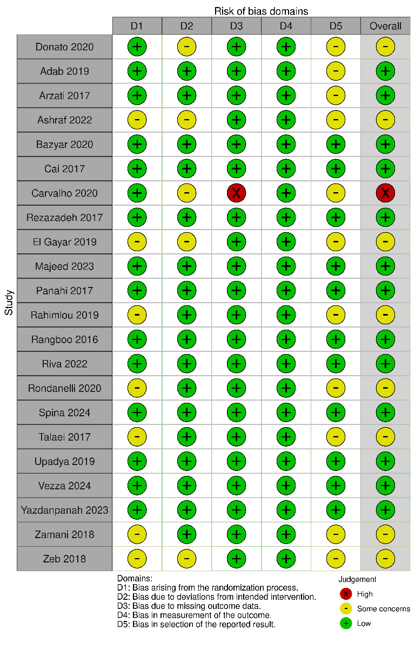
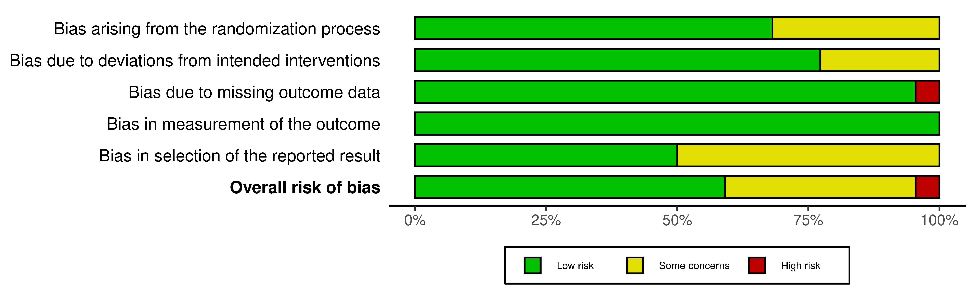

Figure 2. Traffic-Light Plot of RoB2 Tool on RCT studies
The risk of bias of the included randomized controlled trials was assessed using the Cochrane Risk of Bias 2 (RoB 2) tool. Overall, most studies demonstrated low risk of bias, particularly in domains related to outcome measurement and statistical analysis. Randomization procedures were generally well implemented, resulting in a low risk of bias in the randomization domain for the majority of trials.
However, several studies were judged as having some concerns, primarily due to insufficient reporting of allocation concealment and blinding procedures, which may introduce performance bias. Additionally, selective reporting could not be ruled out in some trials due to limited protocol transparency.
Only one study was rated as having high risk of bias, mainly due to incomplete outcome data and reliance on per-protocol analysis, increasing the likelihood of attrition bias. Despite these limitations, the overall body of evidence was considered to have acceptable internal validity.

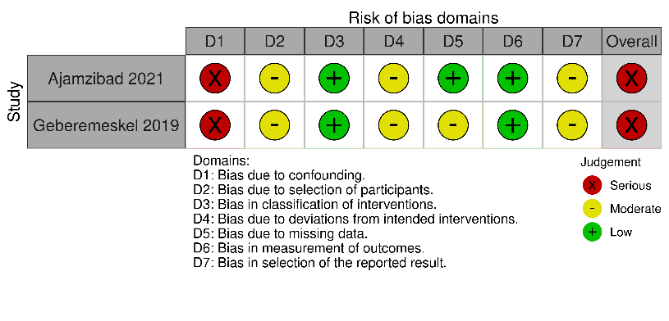
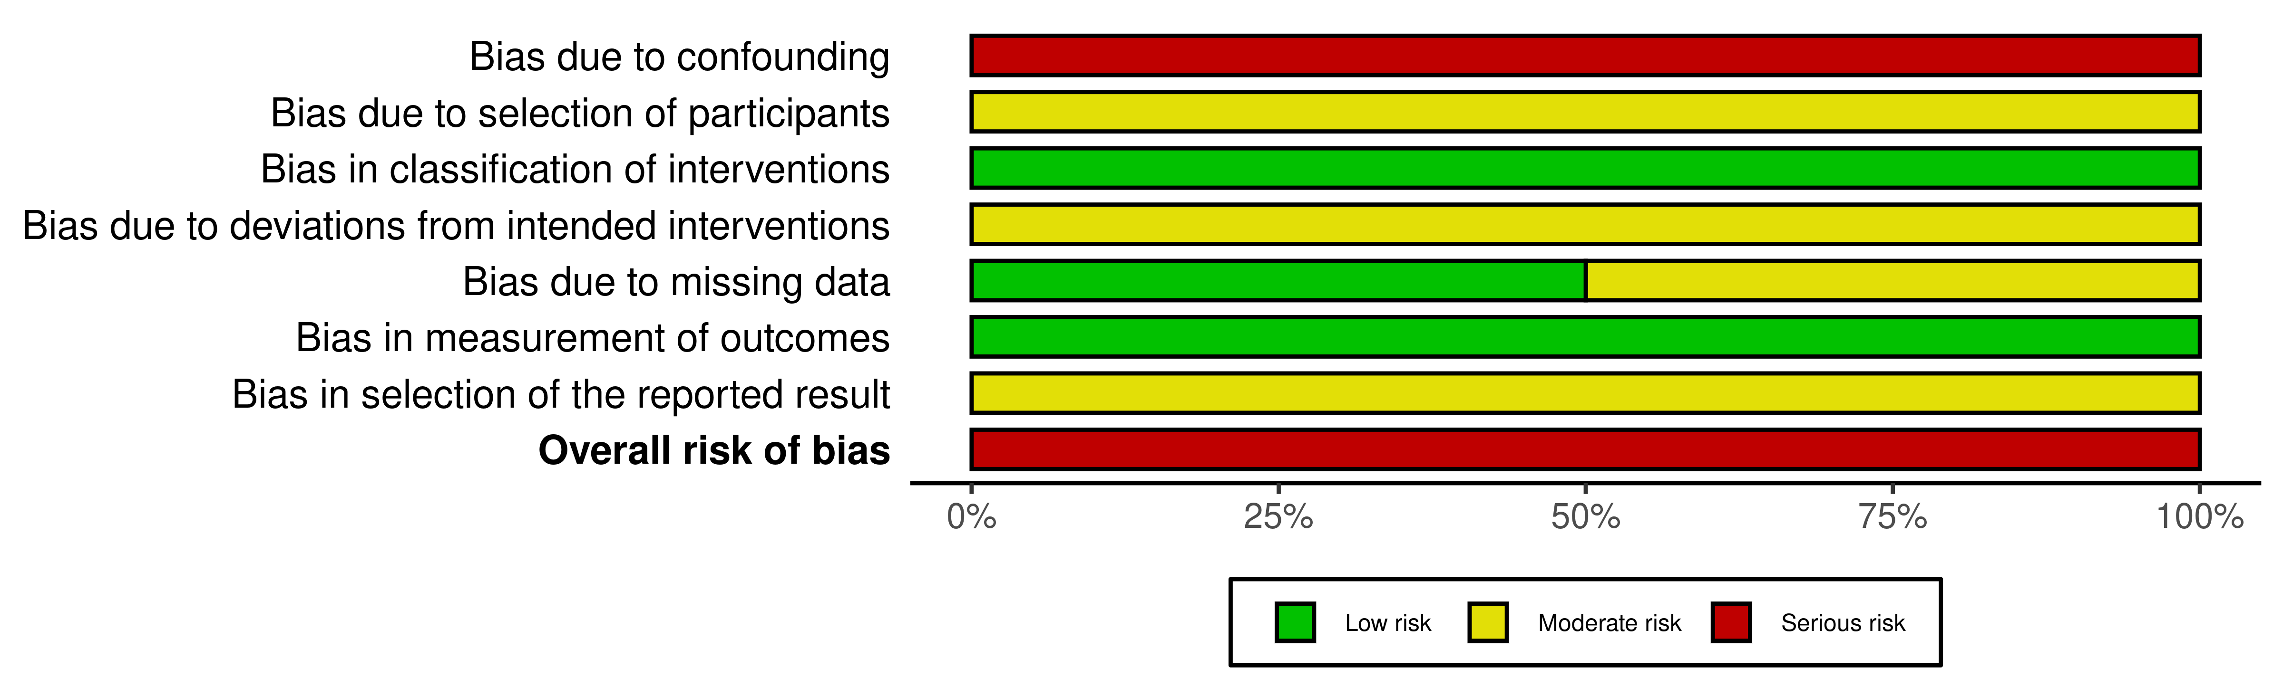

Figure 3. Traffic-Light Plot of ROBINS-I Tool on Quasi experimental studies
The risk of bias for quasi-experimental studies was assessed using the ROBINS-I tool. Both studies were judged to have a serious risk of bias, primarily due to the absence of randomization and limited control of confounding variables. In addition, issues related to participant selection and lack of robust control groups further increased susceptibility to bias.
Although outcome measurements were conducted using reliable methods, the inherent limitations of non-randomized designs—particularly regarding confounding and selection bias—reduce the certainty of causal inference. Therefore, findings from these studies should be interpreted with caution.

Effects on Total Cholesterol
Significant TC reductions were reported with turmeric in hyperlipidemic T2DM, ginger in newly diagnosed obese T2DM, fenugreek in diabetic patients, amla in dyslipidemia, artichoke in NASH, bergamot-based interventions in dyslipidemia and hypercholesterolemia, green tea in T2DM nephropathy, and garlic-based preparations in mild hypercholesterolemia or hypertension-associated dyslipidemia.^{22,25,27,30,31,35,36,38,40-42}
Artichoke-containing interventions appeared particularly relevant. While the nutrigenetic trial in women with metabolic syndrome showed its strongest effect on triglycerides rather than a broad cholesterol response, both the NASH trial and the bergamot-artichoke phytosome trial demonstrated favorable TC reductions, suggesting that Cynara-derived preparations may have context-dependent hypocholesterolemic effects.^{29,35,36} In contrast, not all studies showed superiority over placebo. The Guggulu-Triphala trial found within-group reductions in cholesterol, but these improvements were not clearly better than placebo, illustrating that some herbal formulations may offer limited additional benefit in low-to-moderate cardiovascular-risk populations.²¹
Effects on LDL-C
Low-density lipoprotein cholesterol (LDL-C) was also frequently improved, and in many studies this outcome paralleled the reduction in TC. Significant LDL-C lowering was demonstrated with amla, bergamot extract, bergamot-artichoke phytosome, garlic-onion extract, garlic in hypertensive dyslipidemia, fenugreek, and ginger in newly diagnosed obese T2DM.^{25,27,30,31,36,38,40,41} LDL-C reductions were also reported with turmeric and Calebin A, reinforcing the possibility that Curcuma-derived phytochemicals act on atherogenic fractions more robustly than on all lipid fractions simultaneously.^{22,32} Likewise, the Cynara supplementation trial in overweight adults with impaired fasting glycemia improved LDL-related ratios and apolipoprotein balance, further supporting an antiatherogenic profile beyond simple total cholesterol reduction.³⁷
However, LDL-C responses were not universal. In the curcuminoid trial in T2DM, improvements were stronger for non-HDL cholesterol and lipoprotein(a) than for LDL-C itself, while some ginger studies showed reductions in LDL-C-related ratios without clear superiority for absolute LDL-C values between groups.^{24,33,39} These inconsistencies suggest that some botanicals may exert broader antiatherogenic effects without necessarily producing uniform reductions in every standard lipid fraction.
Effects on HDL-C
Changes in high-density lipoprotein cholesterol (HDL-C) were less consistent than those seen for TC and LDL-C, but several studies still reported favorable increases. HDL-C increased significantly with Calebin A, curcuminoids, green tea at the higher dose, ginger in newly diagnosed obese T2DM, and garlic-containing interventions, especially the garlic-onion and garlic-coriander formulations.^{26,30,32,33,41,42,44} The bergamot-artichoke phytosome trial also described an HDL increase over time, although its most prominent effects remained on TC and LDL-C.³⁶
By contrast, HDL-C changes were neutral or inconsistent in several ginger studies and in some artichoke-based interventions, indicating that HDL may be less responsive to phytotherapy than atherogenic lipids, or may require longer exposure, higher dosage, or more severe baseline dyslipidemia to change meaningfully.^{24,28,29,39}
Effects on Triglycerides
Triglycerides (TG) improved in a substantial proportion of trials, although the effects were more variable than for TC and LDL-C. Strong TG-lowering signals were reported for amla, fenugreek, ginger in metabolic syndrome, turmeric, artichoke in NASH, Calebin A, and ginger in newly diagnosed obese T2DM.^{22,30-32,34,35,40} Boiled garlic with Shirazi lemon and the garlic-coriander combination also produced favorable triglyceride responses, supporting the hypothesis that multi-component plant preparations may act synergistically on triglyceride metabolism.^{23,44}
Nevertheless, not all interventions produced significant TG changes. In the curcuminoid trial, TG was not significantly different between groups despite improvement in other atherogenic indices, and in the bergamot-artichoke phytosome study triglycerides did not emerge as a major responsive outcome.^{33,36} This pattern suggests that triglycerides may be more sensitive to population characteristics such as insulin resistance, obesity, and baseline metabolic syndrome features than to the plant intervention alone.
Comparative Patterns Across Plant Categories
Across plant categories, several patterns emerged. First, bergamot-based interventions showed the most consistent and clinically interpretable reductions in TC and LDL-C across both dyslipidemic and mild hypercholesterolemic populations, whether administered alone or in combination with artichoke.^{27,36,38} Second, Allium-based interventions-including garlic alone, garlic with onion, garlic with coriander, and boiled garlic with lemon-consistently improved one or more major lipid fractions, especially LDL-C, TC, and TG, supporting their central role in phytotherapeutic lipid management.^{23,25,41,44} Third, Curcuma-derived interventions-including turmeric, curcuminoids, and Calebin A-demonstrated favorable though somewhat heterogeneous effects, with repeated benefits on TC, LDL-related parameters, TG, and inflammatory risk-associated profiles.^{22,32,33}
By contrast, ginger-based interventions showed the greatest heterogeneity. Some studies documented clear benefits on TG, TC, LDL-C, and HDL-C, particularly in metabolically compromised populations such as obese new-onset T2DM or metabolic syndrome, whereas others showed only modest effects or improvements in lipid ratios rather than major fractions.^{24,28,30,34,39} This variability likely reflects differences in dose, formulation, treatment duration, concomitant therapies, and metabolic phenotype.
Studies with Neutral or Limited Lipid Effects
Not all eligible studies showed clear lipid-lowering efficacy. Zataria multiflora improved insulin resistance and blood pressure in NAFLD but did not significantly alter lipid profiles, suggesting that not all medicinal plants with metabolic benefits necessarily translate those benefits into direct lipid changes.⁴³ Similarly, the Guggulu-Triphala trial showed no superiority over placebo despite modest within-group improvements, and some ginger studies produced only limited or selective lipid responses.^{21,24,39} These neutral findings are important because they reduce the risk of publication bias in the overall synthesis and indicate that efficacy is not universal across all medicinal plant preparations.
Mechanistic Trends
Although direct mechanistic testing was uncommon, the included studies repeatedly proposed several biologically plausible pathways. Inhibition of cholesterol synthesis, particularly through HMG-CoA reductase-related mechanisms, was frequently invoked for garlic and bergamot preparations, while antioxidant and anti-inflammatory effects were emphasized for turmeric, curcuminoids, green tea, artichoke, and Zataria multiflora.^{22,25,26,33,35,38,41-43} Other studies proposed improved insulin sensitivity, enhanced fatty-acid oxidation, reduced oxidative stress, improved cholesterol efflux, and modulation of signaling pathways such as AMPK and SIRT1 as potential explanations for the observed lipid improvements.^{32,34,38,41}
Overall, the evidence synthesis suggests that medicinal plants exert lipid-lowering effects through multifactorial and partially overlapping mechanisms, rather than through a single dominant biochemical pathway.

DISCUSSION
This review shows that medicinal plant-based interventions have the clearest clinical signal for lowering TC and LDL-C, while HDL-C and TG responses are more dependent on patient phenotype, formulation, and duration. This distinction is important because TC and LDL-C are more directly linked to cholesterol biosynthesis and hepatic clearance pathways, whereas HDL-C and TG are influenced by more complex processes such as reverse cholesterol transport, apolipoprotein metabolism, insulin sensitivity, and VLDL production.
Bergamot, amla, and Allium-based interventions showed especially interpretable LDL-C and TC benefits. These findings are consistent with broader nutraceutical literature suggesting that bergamot polyphenols and garlic preparations may influence cholesterol synthesis and LDL handling.⁴⁵⁻⁴⁸ From a pharmaceutical perspective, these interventions are promising because their proposed mechanisms are biologically plausible and partly overlap with recognized lipid-lowering pathways, although their effect sizes are generally more modest than conventional pharmacotherapy.
Curcuma-derived interventions also demonstrated favorable lipid effects, but the evidence was more heterogeneous. This may reflect differences among turmeric powder, curcuminoid preparations, and isolated minor metabolites such as Calebin A. Curcumin-related compounds are better understood as multi-target agents affecting inflammatory and oxidative pathways, rather than as direct lipid-lowering agents alone.⁴⁹⁻⁵¹ Their clinical value may therefore be greatest in inflammatory or insulin-resistant cardiometabolic phenotypes.
The weaker consistency for HDL-C and TG should not be interpreted as absence of pharmacological activity. HDL-C is regulated by reverse cholesterol transport and multiple enzymes, while TG levels are closely linked to insulin resistance, hepatic VLDL secretion, and adiposity.^{52,53} Plant interventions that improve insulin sensitivity or oxidative stress may reduce TG indirectly, particularly in patients with T2DM or metabolic syndrome.^{54,55}
Compared with statins and emerging lipid-lowering medicines, medicinal plant interventions should not be positioned as replacements for evidence-based pharmacotherapy in high-risk patients. Statins and newer lipid-lowering agents have strong outcome evidence for cardiovascular risk reduction.^{56,57} A more defensible interpretation is that standardized plant-derived products may serve as adjuncts in early dyslipidemia, mild to moderate hypercholesterolemia, or patients seeking complementary options under professional supervision.
Several methodological limitations reduce certainty. First, studies differed in plant species, active compound standardization, dose, duration, and comparator. Second, allocation concealment and blinding were often insufficiently described. Third, many trials were short and focused on surrogate lipid outcomes rather than cardiovascular events. Prior evidence also indicates that effect estimates for natural products may be sensitive to study quality and population heterogeneity.⁵⁸ These issues should be addressed before findings are translated into routine pharmaceutical practice.

4.1 Pharmaceutical implications
The reviewed evidence supports a multi-target pharmacological model in which medicinal plant-derived compounds influence lipid synthesis, oxidative modification of lipoproteins, inflammation, insulin sensitivity, fatty-acid oxidation, and cholesterol transport. However, clinical translation requires more than demonstrating statistical lipid changes. Future trials should specify extract standardization, active compound content, batch consistency, safety monitoring, potential herb-drug interactions, adherence, and clinically meaningful thresholds for lipid reduction.

4.2 Strengths and limitations of this review
This review integrates recent interventional evidence across several medicinal plant categories and interprets lipid outcomes through pharmacological mechanisms. Its limitations include reliance on published trial reports, inability to conduct meta-analysis due to heterogeneity, and the absence of long-term cardiovascular endpoint data. Because the review emphasizes clinical trials, preclinical mechanistic evidence was used only to support interpretation rather than to determine effectiveness.

CONCLUSION
Medicinal plant-based interventions demonstrate significant pharmacological potential in improving lipid profiles, particularly total cholesterol and LDL-C. These findings support their role as adjunct therapeutic agents in dyslipidemia management. Nevertheless, further standardized and well-designed clinical trials are required to establish optimal dosing, formulation, and long-term safety to support their integration into clinical pharmaceutical practice.

REFERENCES
- Brunham LR, Lonn E, Mehta SR. Dyslipidemia and the current state of cardiovascular disease: epidemiology, risk factors, and effect of lipid lowering. Can J Cardiol. 2024;40(8 Suppl):S4-S12. doi:10.1016/j.cjca.2024.04.017
- Du Z, Qin Y. Dyslipidemia and cardiovascular disease: current knowledge, existing challenges, and new opportunities for management strategies. J Clin Med. 2023;12(1):363. doi:10.3390/jcm12010363
- Aliošaitienė U, Petrulionienė Ž, Gabartaite D, Skiauteryte E, Meskene E, Staigyte J, et al. Distribution of total cholesterol and low-density lipoprotein cholesterol between genetically diagnosed familial hypercholesterolaemia men and women in Lithuania. Atherosclerosis. 2022;355:137-138. doi:10.1016/j.atherosclerosis.2022.06.621
- Chew NWS, Ng CH, Tan DJH, Kong G, Lin C, Chin YH, et al. The global burden of metabolic disease: data from 2000 to 2019. Cell Metab. 2023;35(3):414-428.e3. doi:10.1016/j.cmet.2023.02.003
- Liu T, Zhao D, Qi Y. Global trends in the epidemiology and management of dyslipidemia. J Clin Med. 2022;11(21):6377. doi:10.3390/jcm11216377
- Pirillo A, Casula M, Olmastroni E, Norata GD, Catapano AL. Global epidemiology of dyslipidaemias. Nat Rev Cardiol. 2021;18(10):689-700. doi:10.1038/s41569-021-00541-4
- Jacky Xiao Feng H, Adil Y, Julie M, Ramiz A, Krishma U, Pemminati S. Recent advances in the management of dyslipidemia: a systematic review. Cureus. 2025;17(3):e81034. doi:10.7759/cureus.81034
- Maria-Corina S, Colantonio LD, Monda AM, Mues KE, Bittner VA, Banach M, et al. Statin intolerance and risk of coronary heart events and all-cause mortality following myocardial infarction. J Am Coll Cardiol. 2017;69(11):1386-1395. doi:10.1016/j.jacc.2016.12.036
- Zhao X, Cheng T, Xia H, Yang Y, Wang S. Effects of garlic on glucose parameters and lipid profile: a systematic review and meta-analysis on randomized controlled trials. Nutrients. 2024;16(11):1692. doi:10.3390/nu16111692
- Fadillah MA, Indarwati RP, Nur MJ. Literature review: effects of turmeric for reducing lipid profiles. J La Medihealtico. 2024;5(2):445-454. doi:10.37899/journallamedihealtico.v5i2.1273
- Li A, Wang Q, Li P, Zhao N, Liang Z. Effects of green tea on lipid profile in overweight and obese women: a systematic review and meta-analysis of randomized controlled trials. Int J Vitam Nutr Res. 2024;94(3-4):239-251. doi:10.1024/0300-9831/a000783
- Pierdomenico M, Cicero AFG, Veronesi M, Fogacci F, Riccioni C, Benassi B. Effect of Citrus bergamia extract on lipid profile: a combined in vitro and human study. Phytother Res. 2023;37(9):4185-4195. doi:10.1002/ptr.7897
- Ahmed SM, Sabrin F, Mostaqim MS, Jahan S. Effects of Amlaki (Emblica officinalis) on serum lipid profile in rats. Mymensingh Med J. 2022;31(2):360-366.
- Di Napoli A, Germani F, Da Silva S, Senatori L, Parisi F, Zucchetti P. Artichoke (Cynara scolymus L.): a review of its health-promoting properties. 2023. doi:10.22541/au.169516741.12075156/v1
- Abdollahi A, Adelibahram F, Ghassab-Abdollahi N, Araj-khodaei M, Parsian Z, Mirghafourvand M. The effect of Salvia officinalis on blood glycemic indexes and blood lipid profile in diabetic patients: a systematic review and meta-analysis. J Complement Integr Med. 2023;20(3):521-529. doi:10.1515/jcim-2021-0425
- Hassanpour H, Mojtahed M, Fallah AA, Jafari T. Lamiaceae plants improve serum cholesterol, triglyceride, and LDL in patients with metabolic syndrome: a systematic review and meta-analysis of randomized clinical trials. Food Sci Nutr. 2024;12(11):8525-8539. doi:10.1002/fsn3.4451
- Page MJ, McKenzie JE, Bossuyt PM, Boutron I, Hoffmann TC, Mulrow CD, et al. The PRISMA 2020 statement: an updated guideline for reporting systematic reviews. BMJ. 2021;372:n71. doi:10.1136/bmj.n71
- Joanna Briggs Institute. Critical appraisal tools. Adelaide: Joanna Briggs Institute; 2024.
- Sterne JAC, Savović J, Page MJ, Elbers RG, Blencowe NS, Boutron I, et al. RoB 2: a revised tool for assessing risk of bias in randomised trials. BMJ. 2019;366:l4898. doi:10.1136/bmj.l4898
- Sterne JAC, Hernán MA, Reeves BC, Savović J, Berkman ND, Viswanathan M, et al. ROBINS-I: a tool for assessing risk of bias in non-randomised studies of interventions. BMJ. 2016;355:i4919. doi:10.1136/bmj.i4919
- Donato F, Raffetti E, Toninelli G, Festa A, Scarcella C, Castellano M. Guggulu and Triphala for the treatment of hypercholesterolaemia: a placebo-controlled, double-blind, randomised trial. Complement Med Res. 2021;28(3):216-225. doi:10.1159/000510985
- Adab Z, Eghtesadi S, Vafa MR, Heydari I, Shojaii A, Haqqani H, et al. Effect of turmeric on glycemic status, lipid profile, hs-CRP, and total antioxidant capacity in hyperlipidemic type 2 diabetes mellitus patients. Phytother Res. 2019;33(4):1173-1181. doi:10.1002/ptr.6312
- Ajamzibad H, Baloochi Beydokhti T, Mohtasham F, Nematollahi MR. Effects of boiled garlic and Shirazi lemon on blood lipids in hyperlipidemic patients: a quasi-experimental study. J Herb Med. 2021;28:100439. doi:10.1016/j.hermed.2021.100439
- Arzati MM, Honarvar NM, Saedisomeolia A, Anvari S, Effatpanah M, Arzati RM, et al. The effects of ginger on fasting blood sugar, hemoglobin A1c, and lipid profiles in patients with type 2 diabetes. Int J Endocrinol Metab. 2017;15(4):e57927. doi:10.5812/ijem.57927
- Ashraf R, Sarwar M, Kamil N, Wahid S, Qureshi A. Analysis of dose and duration dependent effects of Allium sativum Linn and other hypocholesterolemic agents exhibited on dyslipidemia in patients with essential hypertension. Pak J Pharm Sci. 2022;35(3):777-784. doi:10.36721/PJPS.2022.35.3.REG.777-784.1
- Bazyar H, Hosseini SA, Saradar S, Mombaini D, Allivand M, Labibzadeh M, et al. Effects of epigallocatechin-3-gallate of Camellia sinensis leaves on blood pressure, lipid profile, atherogenic index of plasma and some inflammatory and antioxidant markers in type 2 diabetes mellitus patients: a clinical trial. J Complement Integr Med. 2021;18(2):405-411. doi:10.1515/jcim-2020-0090
- Cai Y, Xing G, Shen T, Zhang S, Rao J, Shi R. Effects of 12-week supplementation of Citrus bergamia extracts-based formulation CitriCholess on cholesterol and body weight in older adults with dyslipidemia: a randomized, double-blind, placebo-controlled trial. Lipids Health Dis. 2017;16(1):251. doi:10.1186/s12944-017-0640-1
- Carvalho GCN, Lira-Neto JCG, Araújo MFM, Freitas RWJF, Zanetti ML, Damasceno MMC. Effectiveness of ginger in reducing metabolic levels in people with diabetes: a randomized clinical trial. Rev Lat Am Enfermagem. 2020;28:e3369. doi:10.1590/1518-8345.3870.3369
- Rezazadeh K, Rahmati-Yamchi M, Mohammadnejad L, Ebrahimi-Mameghani M, Delazar A. Effects of artichoke leaf extract supplementation on metabolic parameters in women with metabolic syndrome: influence of TCF7L2-rs7903146 and FTO-rs9939609 polymorphisms. Phytother Res. 2018;32(1):84-93. doi:10.1002/ptr.5951
- El Gayar MH, Aboromia MMM, Ibrahim NA, Abdel Hafiz MH. Effects of ginger powder supplementation on glycemic status and lipid profile in newly diagnosed obese patients with type 2 diabetes mellitus. Obes Med. 2019;14:100094. doi:10.1016/j.obmed.2019.100094
- Geberemeskel GA, Debebe YG, Nguse NA. Antidiabetic effect of fenugreek seed powder solution (Trigonella foenum-graecum L.) on hyperlipidemia in diabetic patients. J Diabetes Res. 2019;2019:8507453. doi:10.1155/2019/8507453
- Majeed M, Nagabhushanam K, Devarajan TV, Saklecha S, Reddy SVK, Mundkur L. A minor metabolite from Curcuma longa effective against metabolic syndrome: results from a randomized, double-blind, placebo-controlled clinical study. Food Funct. 2023;14(10):4722-4733. doi:10.1039/d2fo03627d
- Panahi Y, Khalili N, Sahebi E, Namazi S, Reiner Ž, Majeed M, et al. Curcuminoids modify lipid profile in type 2 diabetes mellitus: a randomized controlled trial. Complement Ther Med. 2017;33:1-5. doi:10.1016/j.ctim.2017.05.006
- Rahimlou M, Yari Z, Rayyani E, Keshavarz SA, Hosseini S, Morshedzadeh N, et al. Effects of ginger supplementation on anthropometric, glycemic and metabolic parameters in subjects with metabolic syndrome: a randomized, double-blind, placebo-controlled study. J Diabetes Metab Disord. 2019;18(1):119-125. doi:10.1007/s40200-019-00397-z
- Rangboo V, Noroozi M, Zavoshy R, Rezadoost SA, Mohammadpoorasl A. The effect of artichoke leaf extract on alanine aminotransferase and aspartate aminotransferase in patients with nonalcoholic steatohepatitis. Int J Hepatol. 2016;2016:4030476. doi:10.1155/2016/4030476
- Riva A, Petrangolini G, Allegrini P, Perna S, Giacosa A, Peroni G, et al. Artichoke and bergamot phytosome alliance: a randomized double blind clinical trial in mild hypercholesterolemia. Nutrients. 2022;14(1):108. doi:10.3390/nu14010108
- Rondanelli M, Riva A, Petrangolini G, Allegrini P, Bernardinelli L, Fazia T, et al. The metabolic effects of Cynara supplementation in overweight and obese class I subjects with newly detected impaired fasting glycemia: a double-blind, placebo-controlled, randomized clinical trial. Nutrients. 2020;12(11):3298. doi:10.3390/nu12113298
- Spina A, Amone F, Zaccaria V, Insolia V, Perri A, Lofaro D, et al. Citrus bergamia extract, a natural approach for cholesterol and lipid metabolism management: a randomized, double-blind placebo-controlled clinical trial. Foods. 2024;13(23):3883. doi:10.3390/foods13233883
- Talaei B, Mozaffari-Khosravi H, Bahreini S. The effect of ginger on blood lipid and lipoproteins in patients with type 2 diabetes: a double-blind randomized clinical controlled trial. J Nutr Food Secur. 2017;2(1):76-85.
- Upadya H, Prabhu S, Prasad A, Subramanian D, Gupta S, Goel A. A randomized, double blind, placebo controlled, multicenter clinical trial to assess the efficacy and safety of Emblica officinalis extract in patients with dyslipidemia. BMC Complement Altern Med. 2019;19(1):27. doi:10.1186/s12906-019-2430-y
- Vezza T, Guillamón E, García-García J, Baños A, Mut-Salud N, García-López JD, et al. LDL-cholesterol-lowering effects of a dietary supplement containing onion and garlic extract used in healthy volunteers. Nutrients. 2024;16(16):2811. doi:10.3390/nu16162811
- Yazdanpanah Z, Salehi-Abargouei A, Mozaffari Z, Hemayati R. The effect of green tea (Camellia sinensis) on lipid profiles and renal function in people with type 2 diabetes and nephropathy: a randomized controlled clinical trial. Front Nutr. 2023;10:1253275. doi:10.3389/fnut.2023.1253275
- Zamani N, Shams M, Nimrouzi M, Zarshenas MM, Abolhasani Foroughi A, Fallahzadeh Abarghooei E, et al. The effects of Zataria multiflora Boiss. on nonalcoholic fatty liver disease and insulin resistance: a randomized double-blind placebo-controlled clinical trial. Complement Ther Med. 2018;41:118-123. doi:10.1016/j.ctim.2018.09.010
- Zeb F, Safdar M, Fatima S, Khan S, Alam S, Muhammad M, et al. Supplementation of garlic and coriander seed powder: impact on body mass index, lipid profile and blood pressure of hyperlipidemic patients. Pak J Pharm Sci. 2018;31(5):1935-1941.
- Carpenito M, Coletti F, Muscoli S, Guarino L, Di Cristo A, Cammalleri V, et al. Unveiling the power of bergamot: beyond lipid-lowering effects. Nutrients. 2025;17(11):1871. doi:10.3390/nu17111871
- Sadeghi-dehsahraei H, Esmaeili Gouvarchin Ghaleh H, Mirnejad R, Parastouei K. The effect of bergamot supplementation on lipid profiles: a systematic review and meta-analysis of randomized controlled trials. Phytother Res. 2022;36(12):4409-4424. doi:10.1002/ptr.7647
- Du Y, Zhou H, Zha W. Garlic consumption can reduce the risk of dyslipidemia: a meta-analysis of randomized controlled trials. J Health Popul Nutr. 2024;43(1):113. doi:10.1186/s41043-024-00608-1
- Fu Z, Lv J, Gao X, Zheng H, Shi S, Xu X, et al. Effects of garlic supplementation on components of metabolic syndrome: a systematic review, meta-analysis, and meta-regression of randomized controlled trials. BMC Complement Med Ther. 2023;23(1):260. doi:10.1186/s12906-023-04038-0
- Cui J, Li H, Zhang T, Lin F, Chen M, Zhang G, et al. Research progress on the mechanism of curcumin anti-oxidative stress based on signaling pathway. Front Pharmacol. 2025;16:1548073. doi:10.3389/fphar.2025.1548073
- Gao J, Liu Y, Chen J, Tong C, Wang Q, Piao Y. Curcumin treatment attenuates cisplatin-induced gastric mucosal inflammation and apoptosis through the NF-κB and MAPKs signaling pathway. Hum Exp Toxicol. 2022;41:9603271221128738. doi:10.1177/09603271221128738
- Zamanian MY, Alsaab HO, Golmohammadi M, Yumashev A, Jabba AM, Abid MK, et al. NF-κB pathway as a molecular target for curcumin in diabetes mellitus treatment: focusing on oxidative stress and inflammation. Cell Biochem Funct. 2024;42(4):e4030. doi:10.1002/cbf.4030
- Alcover S, Ramos-Regalado L, Girón G, Muñoz-García N, Vilahur G. HDL-cholesterol and triglycerides dynamics: essential players in metabolic syndrome. Antioxidants. 2025;14(4):434. doi:10.3390/antiox14040434
- Choi SH, Ginsberg HN. Increased very low density lipoprotein secretion, hepatic steatosis, and insulin resistance. Trends Endocrinol Metab. 2011;22(9):353-363. doi:10.1016/j.tem.2011.04.007
- Alkhatib DH, Jaleel A, Tariq MNM, Feehan J, Apostolopoulos V, Ismail LC, et al. The role of bioactive compounds from dietary spices in the management of metabolic syndrome: an overview. Nutrients. 2022;14(1):175. doi:10.3390/nu14010175
- Ferrara L, Joksimovic M, D'Angelo S. Could polyphenolic food intake help in the control of type 2 diabetes? A narrative review of the last evidence. Curr Nutr Food Sci. 2022;18(9):785-798. doi:10.2174/1573401318666220317140717
- Capuozzo M, Ottaiano A, Cinque C, Farace S, Ferrara F. Cutting-edge lipid-lowering pharmacological therapies: improving lipid control beyond statins. Hipertens Riesgo Vasc. 2025;42(2):116-127. doi:10.1016/j.hipert.2024.12.002
- Luo F, Yu L, Xian X, Shan B, Das A. Editorial: new and emerging lipid-lowering therapies for reducing cardiovascular risk: beyond statins. Front Cardiovasc Med. 2024;11:1364170. doi:10.3389/fcvm.2024.1364170
- Fakhri M, Fakheri H, Azadbakht M, Moosazadeh M, Yousefi SS. Effect of medicinal plants and natural products on liver enzymes in non-alcoholic fatty liver patients in Iran: a systematic review and meta-analysis. Int J Prev Med. 2022;13:87.

